Super Store Sales Analysis

1. Introduction
In today’s data-driven world, businesses heavily rely on analytics to improve decision-making and operational efficiency. Retail industries especially generate massive volumes of transactional data, which can be analyzed to uncover patterns in customer behavior, product demand, and regional performance.
This project focuses on analyzing a Super Store Orders dataset using Power BI to extract meaningful insights related to sales, shipping cost, discount distribution, and order priority. By visualizing data through interactive dashboards, the project aims to support better business strategies, optimize logistics, and improve customer satisfaction.

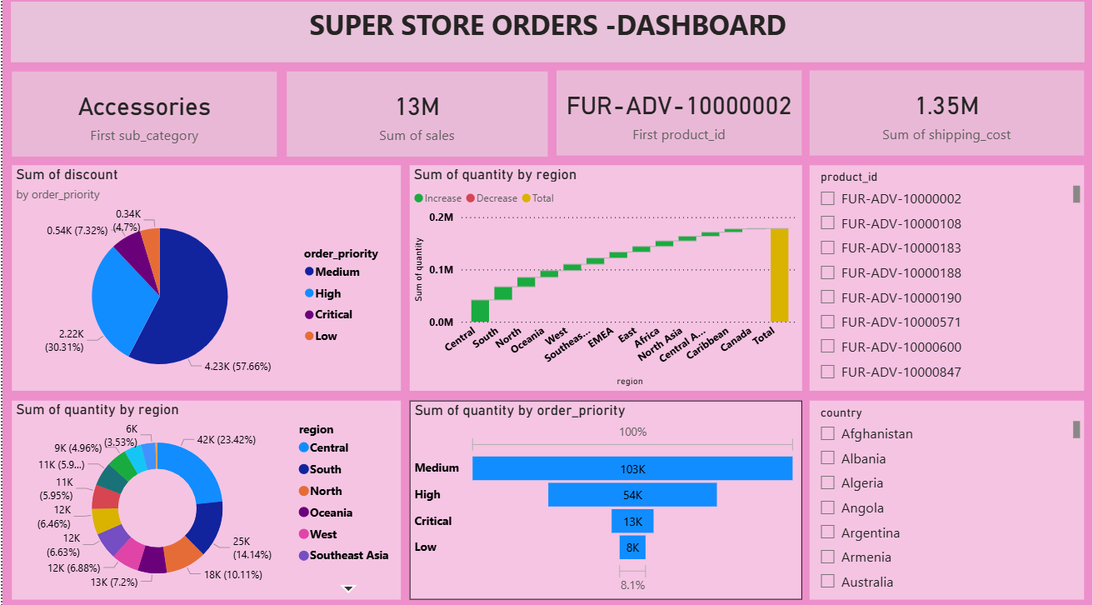
2. Objective of the Project
The main objectives of this project are:
- To analyze overall sales performance across different regions and categories
- To identify high-performing and low-performing products
- To study the impact of discount and shipping cost on sales
- To understand order priority distribution and its influence on quantity
- To create an interactive dashboard for decision-making

3. Dataset Description
The dataset used in this project contains detailed information about superstore orders, including:
- Product ID – Unique identifier for each product
- Category & Sub-category – Product classification (e.g., Accessories)
- Sales – Total revenue generated
- Quantity – Number of units sold
- Discount – Discount applied on orders
- Shipping Cost – Cost incurred for delivery
- Region & Country – Geographical data
- Order Priority – Low, Medium, High, Critical
This dataset enables a comprehensive analysis of business performance across multiple dimensions.

4. Tools and Technologies Used
- Power BI – For data visualization and dashboard creation
- Microsoft Excel – Data preprocessing
- DAX (Data Analysis Expressions) – For calculated measures

5. Methodology
The project follows a structured approach:
1. Data Collection
Dataset was imported into Power BI from Excel format.
2. Data Cleaning
- Removed null values
- Standardized column names
- Verified data consistency
3. Data Transformation
- Created calculated columns and measures
- Aggregated sales, quantity, and discount values
4. Dashboard Development
Multiple visualizations were created:
- KPI Cards (Sales, Shipping Cost, Product ID)
- Pie Charts
- Bar Charts
- Donut Charts
- Region-based analysis

6. Dashboard Explanation
Sales Overview
- Total Sales: 13M
- Shipping Cost: 1.35M
- Top Category: Accessories

Discount Analysis
- Maximum discount applied to Medium priority orders (57.66%)
- High and Critical orders receive less discount

Regional Analysis
- Highest quantity sold in Central region (42K units)
- Other regions like South, North contribute moderately

Order Priority Analysis
- Medium priority orders: 103K (highest)
- High: 54K
- Critical & Low are comparatively less

Product Analysis
- Product ID FUR-ADV-10000002 appears frequently.

7. Key Findings
- Medium priority orders dominate both sales and discount allocation
- Central region contributes the highest sales volume
- Shipping cost is relatively high, indicating optimization opportunity
- Few products generate a large portion of revenue (Pareto principle)
- Discounts significantly influence purchase behavior

8. Advantages of the Project
- Helps businesses understand customer purchasing trends
- Supports data-driven decision making
- Identifies profitable regions and products
- Improves inventory and logistics planning

9. Limitations
- Dataset is static (real-time data not included)
- External factors like seasonality not considered
- Limited predictive analysis

10. Future Enhancements
- Implement Machine Learning for sales prediction
- Add real-time dashboard updates
- Integrate customer segmentation analysis
- Develop automated recommendation system

11. Conclusion
This project successfully demonstrates how data analytics can be used to transform raw business data into actionable insights. By leveraging Power BI, the Super Store dataset was analyzed effectively to identify sales trends, regional performance, and customer behavior patterns. The insights gained from this dashboard can help organizations optimize operations, reduce costs, and enhance overall profitability.

